EXPERIMENT-5
NAME: Yuvaraj A ROLL NO:240701809
Conduct task analysis for an app and document user flows. Create corresponding wireframes using Lucidchart.
FLOWCHART FOR CAMPUS LOST AND FOUND APP :
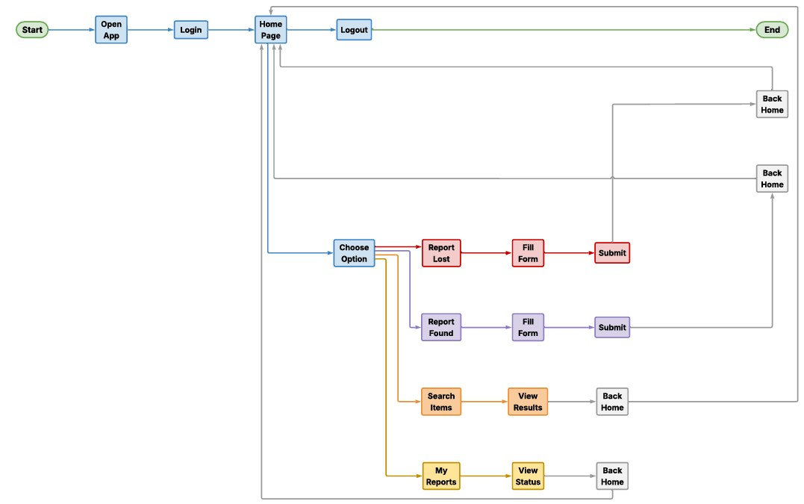
FLOWCHART DESCRIPTION:
- Start – User opens the Campus Lost & Found app.
- Login Process – User enters email and password to log in.
- Home Page – After successful login, the user reaches the dashboard.
- Search Items – User searches for lost or found items and views results.
- Report Lost Item – User fills the lost item form and submits the report.
- Report Found Item – User fills the found item form and submits the report.
- My Reports – User views submitted reports and checks status.
- Back Home – After completing any action, the user returns to the home page.
- Logout – User logs out of the app.
- End – Session ends successfully.
WIREFRAME FOR CAMPUS LOST AND FOUND APP :

Screen 1: Login Screen

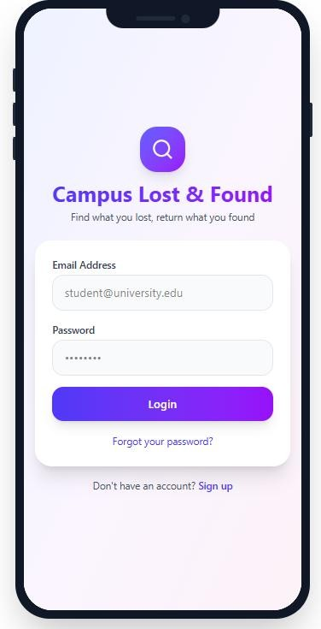

Screen 2 : Home Dashboard

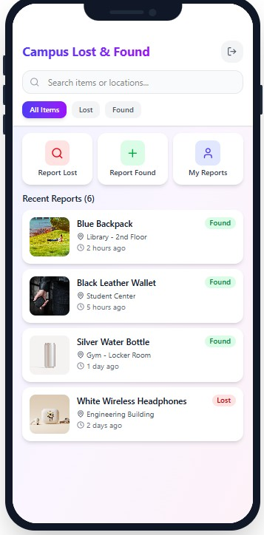

Screen 3 : Report Found Item Screen

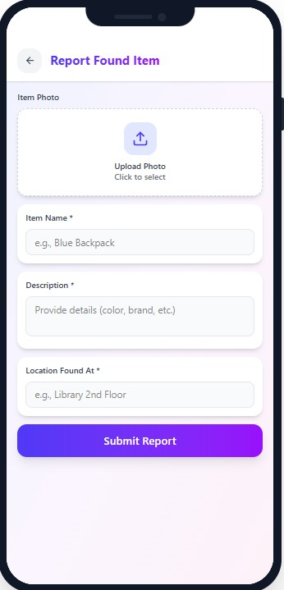

Screen 4 : My Reports Screen

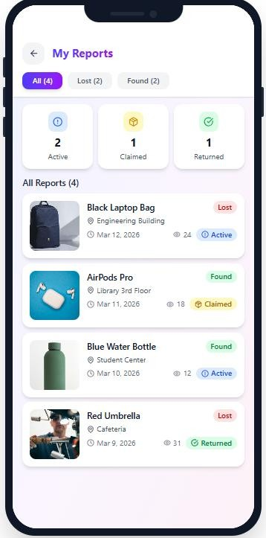

Lucid chart prototype link :

https://lucid.app/lucidchart/80b02f1a-bb89-4747-8ac83ff0c2e6cdcb/edit?viewport_loc=-933%2C-
2642%2C4138%2C2267%2C0_0&invitationId=inv_c9cfdce5-648c-4a06-8f8e-
57c19a59ca43

